Project Plan

|  |  |
| --- | --- |
| Student Name | Muhammad kemal |
| Student ID | BDSE07-0922-084/STTB |
| Centre Name | Lithan EduClaas |
| Mentor | Arvinder Kaur |
| Date | **05th Sep 2023** |
| Qualification Name | Applied Degree in Software Engineering  Higher Diploma in Software Engineering |
| Milestone | Project Plan |
| Module Name (BDSE) | Capstone Project – Application Development |
| Project Title | **"Enhancing Features and Revitalizing Jumpstart Website to Fit Post-COVID-19 User Preferences"** |

1. **Introduction**

In the wake of the global COVID-19 pandemic, the digital landscape has undergone an unprecedented transformation. The way users interact with websites and online platforms has evolved significantly as preferences shift towards a more fluid, efficient and user-friendly experience. In this dynamic environment, the project “Feature Enhancement and Revitalization of Jumpstart Website to Fit Post-COVID-19 User Preferences” emerged as a strategic initiative to not only adapt but thrive in the new normal.

The Jumpstart website has long been a cornerstone, our online presence serving as a valuable resource and communication channel for our users. As we face the challenges and opportunities posed by the post-COVID-19 era, our aim is clear, namely to ensure that our website remains not only relevant but also a destination of choice for our users.

**2.0 Scope**

The scope of this project includes the following:

2.1 Implementation of a New Software System

This project will entail the development and integration of a modern software system designed to revolutionize our customer data management processes. The new system will be tailored to address the specific needs and challenges of our organization.

2.2 Data Migration from the Old System to the New System

The transition to the new software system will involve the seamless migration of existing customer data from our current system to the newly implemented one. This meticulous data transfer will ensure the continuity and accuracy of our records.

2.3 User Training and Support

To ensure a smooth transition and effective utilization of the new software, comprehensive training programs will be conducted for all relevant personnel. Continuous support will also be provided to address any queries or issues that may arise during and after implementation.

2.4 System Maintenance and Upgrades

Post-implementation, the project will include a proactive system maintenance plan. Regular updates and upgrades will be carried out to ensure the system remains efficient, secure, and aligned with evolving industry standards.

**3.0 Objectives**

3.1 Improve the Accuracy and Efficiency of the Customer Data Management Process

One of the primary objectives is to enhance the precision and efficiency of our customer data management. The new system will minimize errors and streamline data handling, resulting in more reliable records.

3.2 Increase the Speed of Customer Data Retrieval

We aim to significantly reduce the time it takes to access critical customer information. Faster data retrieval will empower our teams to provide quicker and more informed responses to customer inquiries and requests.

3.3 Reduce Time Spent on Manual Data Entry and Management

Manual data entry can be time consuming and prone to errors. This project seeks to minimize manual tasks, freeing up valuable resources for more strategic and customer-centric activities.

3.4 Improve the Quality of Customer Service Provided to Customers

By optimizing our customer data management processes, we aspire to elevate the quality of customer service we offer. This, in turn, will enhance customer satisfaction, foster stronger relationships and loyalty within our customer base.

**4.0 Milestones /WBS/Gant Chart**

The following milestones will be achieved during this project:

|  |  |  |
| --- | --- | --- |
| **Milestone** | **Target Date** | **Deliverable** |
| 1 | 1 September 2023 | Completed research on customer experience and made new design assumptions |
| 2 | 4 September 2023 | Create a feasibility document and objective for the project |
| 3 | 5 September 2023 | Document the comprehensive project plane detailing the project objective task timeline and responsibilities |
| 4 | 7 September 2023 | Implementation of the new business models system |
| 5 | 16 September 2023 | Document sales promotion highlighting the benefits and business value of the dazzling new model |
| 6 | 21 September 2023 | Completing application testing debugging and making sure everything is ready |

**WBS**

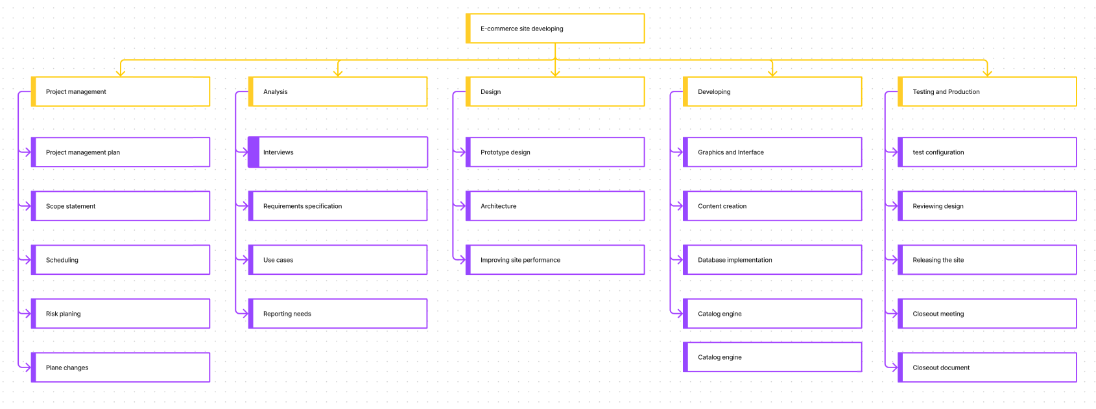

**5.0 Budget**

The following is the budget for this project:

|  |  |  |  |
| --- | --- | --- | --- |
|  |  | items |  |
| No | Software |  | Total |
| 1 | Hardware | -Intel Core i5 atau AMD Ryzen 5.  -8GB RAM DDR4  -1TB  - SSD SATA 240GB  - Gigabit Network  - Asus TUF VG328H1B 31.5"  - Prime Titanium TX-1000 - 500W 80+ Titanium Certified  - USB Mouse Keyboard Standart | $2000 |
| 2 | Software | -Windows 10 / Windows 11  - CMS WordPress  - Google Chrome, Mozilla Firefox, etc | $1000 |
| 3 | Human resource | Hire and manage the development team and other personnel as required | $27900 |

**6.0 Risk**

|  |  |  |  |
| --- | --- | --- | --- |
| Risk | Impact | Likelihood | Mitigation Strategy |
| Data loss during migration | High | Low | Backup data before migration and test migration process |
| User resistance to new system | Medium | Medium | Provide thorough training and support to users |
| Software compatibility issues | High | Medium | Test software thoroughly before implementation and have a contingency plan in place |

**Testing Plan**

|  |  |  |
| --- | --- | --- |
| Test Scenario ID | Test Scenario | Number of test cases |
| TS001-Unit testing | Ensure SQLI is prevented | 3 |
| TS002-Cross Browser testing | Ensure website is compatible with multiple browser | 3 |
| TS003-UAT testing | 1. Ensure user navigation is easy | 2 |

**Database Design**

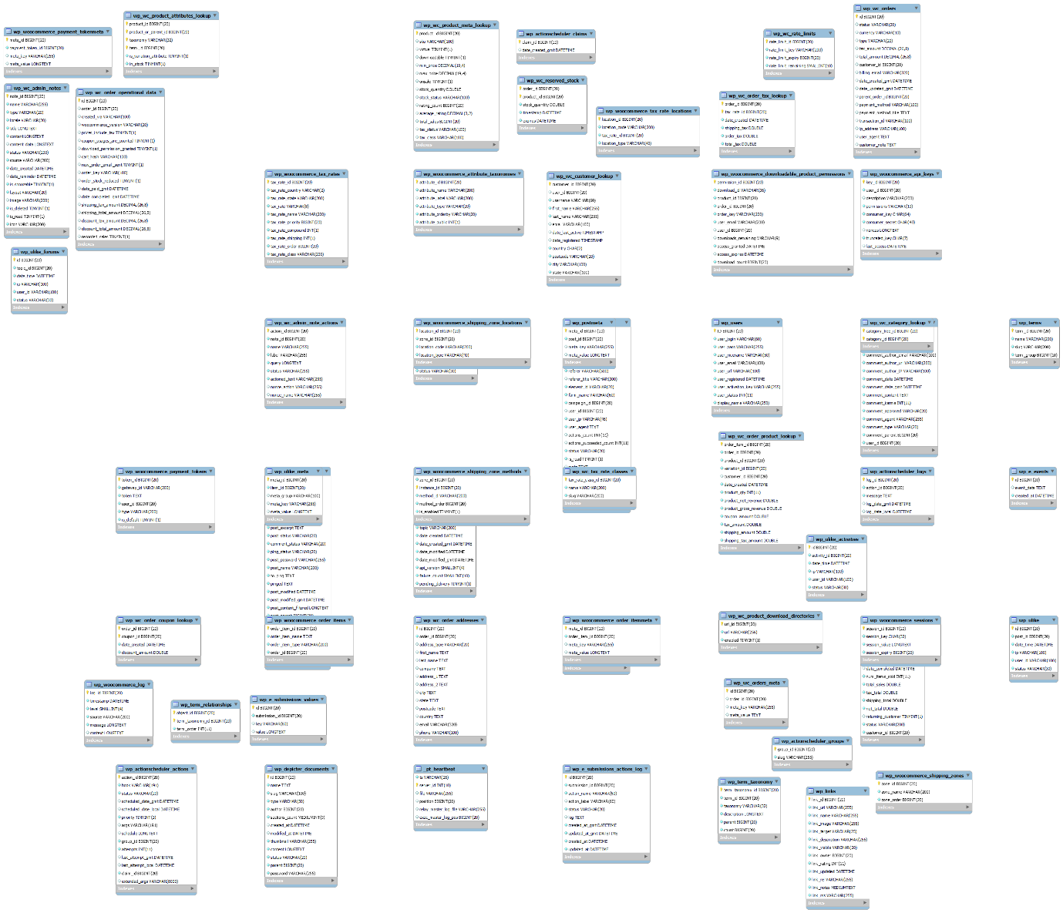

**Flow Chart**

